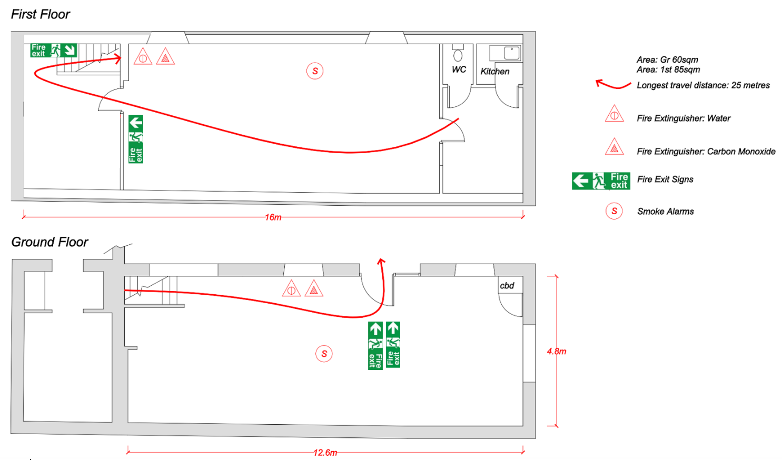

Fire Risk Assessment & Procedures

ON DISCOVERING A FIRE

1. Sound the alarm.
2. Dial 999 to call the Fire Brigade.
3. If possible, tackle the fire using the appliances provided. (Do not endanger yourself or others in doing so).

ON HEARING THE FIRE ALARM

4. Leave the building by the Front Door
5. Close all doors behind you.
6. Report to person in charge of your assembly point at:- The Junction of Durngate Street and Acland Road (Citizens Advice Bureau)

Do not take risks.
Do not stop to collect personal belongings.
Do not re-enter the building for any reason unless authorised to do so.

Fire Hazards

Sources of Ignition
Heaters, Task Lighting, Electrical Equipment (E.g. Lathe, Bandsaw, Rotary Tools), Naked Flames (E.g. soldering torches)

Sources of Fuel
Butane gas, White Spirit, Paints and dyes, Adhesives
Wood shavings, Wood blocks, Paper, Canvas, Textiles, Willow, Craft Materials, Waste bins, Hanging coats and aprons.
The building is kept very well ventilated due to processes such as soldering.

People at Risk
Students, Tutors, Models, Temporary workers, Users of adjoining premises (Hairdressers)
People with sensory and mobility impairments

Risk Reduction

- Tutors have completed fire risk assessments for their own equipment, materials, and procedures
- Students are supervised at all times
- Tutors have discussed fire evacuation with their students (especially those with sensory/mobility impairments)
- Electrical equipment is subject to Portable Appliance Testing (PAT) on a regular basis
- Incendiary substances are only kept in small quantities and in appropriate containers and storage.
- Flammable materials are kept separately from sources of ignition
- Workspaces are kept clean and tidy and waste removed regularly

Detection and warning – Mains Powered smoke and heat alarms (G floor) and Battery smoke alarm (1st)
Fire-fighting - 6L Water and 2Kg CO2 wall-mounted extinguishers on each floor, photoluminescent ID signage
Escape routes – 900mm min escape route via stairs and ground floor kept clear at all times
Lighting - 4 x bulkhead-style Emergency Lights (to be provided)
Signs and notices - ‘Running Man’, Extinguisher use, Fire Escape Keep Clear, Fire Action Notice
Maintenance – Alarms Weekly, PAT Yearly,
Training – All tutors at first use.

Currently soliciting quotations 2/24

