

Policy Pack

V1 January 2024
Contents:

Liability 3
Fire 3
Reporting of Injuries, Diseases and Dangerous Occurrences Regulations 2013 (RIDDOR) 5
Control of Substances Hazardous to Health Regulations (COSHH) 5
Safeguarding 6
Equality & Diversity policy 8
Data Protection (GDPR) 10

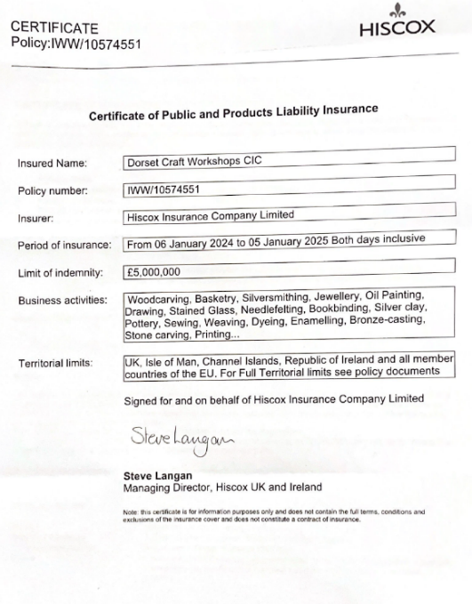
Liability
Dorset Craft Workshops is committed to providing a safe environment for it’s tutors and students. We have an overarching Liability Insurance cover. Nevertheless all of our Tutors are individually responsible for meeting the full health and safety regulations and for providing safety advice, risk assessment and the appropriate insurance cover for their Courses, Equipment and Materials.

Fire
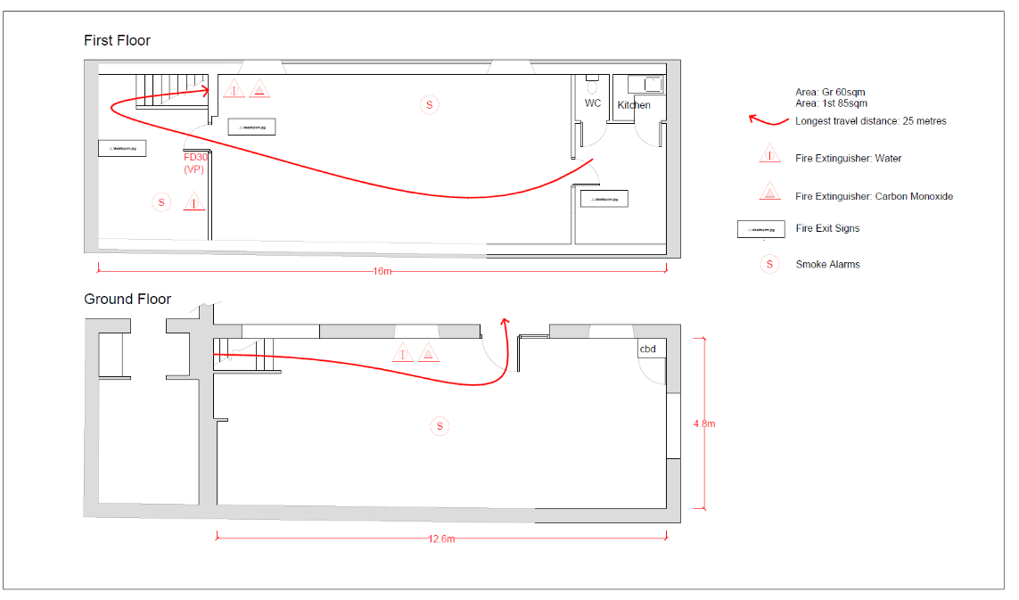
Responsibilities for short-term hiring or leasing and for shared use
The fire safety responsibilities of tutors leasing space in the building (and, therefore, in charge of the activities conducted within the building), and those of the owner/leasee, are to be established as part of the contract of hire.
The responsible person for each individual unique, occasional or separate function needs to be clearly documented, and tutors’ legal duties are made clear to them. In particular, and where necessary, the responsible person will need to take account of their own lack of familiarity with the layout of the premises, the fire safety provisions, and the duties of other responsible persons within the premises.
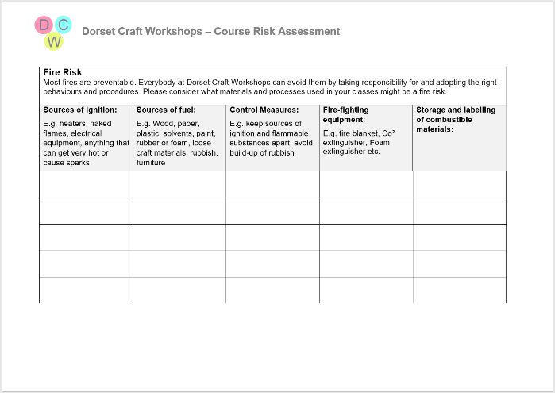
A pro forma risk assessment template is provided for tutors which includes a section to record control measures for Fire Safety and used to update the Fire Risk Assessment.

Overarching Fire Risk Reduction

- Tutors have completed fire risk assessments for their own equipment, materials, and procedures
- Students are supervised at all times
- Tutors have discussed fire evacuation with their students (especially those with sensory/mobility impairments)
- Electrical equipment is subject to Portable Appliance Testing (PAT) on a regular basis
- Incendiary substances are only kept in small quantities and in appropriate containers and storage.
- Flammable materials are kept separately from sources of ignition
- Workspaces are kept clean and tidy and waste removed regularly

Detection and warning – Mains Powered smoke and heat alarms (G floor) and Battery smoke alarm (1st)
Fire-fighting - 6L Water and 2Kg CO2 wall-mounted extinguishers on each floor, photoluminescent ID signage
Escape routes – 900mm min escape route via stairs and ground floor kept clear at all times
Lighting - 4 x bulkhead-style Emergency Lights to be provided
Signs and notices - ‘Running Man’, Extinguisher use, Fire Escape Keep Clear, Fire Action Notice
Maintenance – Alarms Weekly, PAT Yearly,
Training – All tutors at first use.

Reporting of Injuries, Diseases and Dangerous Occurrences Regulations 2013 (RIDDOR)
RIDDOR is the law that requires employers, and other people in charge of work premises, to report and keep records of:
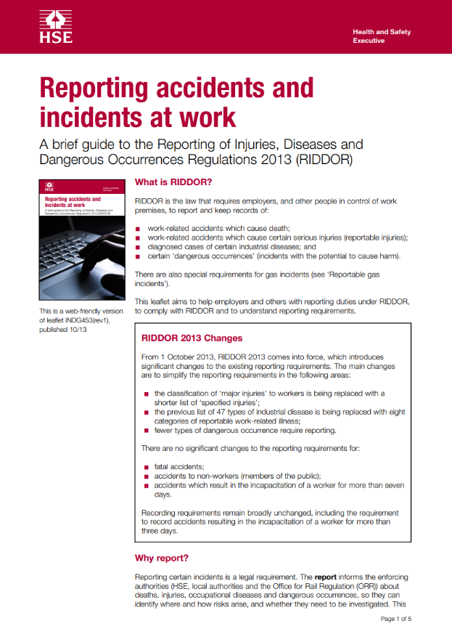
work-related accidents which cause deaths
work-related accidents which cause certain serious injuries (reportable injuries)
diagnosed cases of certain industrial diseases; and
certain 'dangerous occurrences' (incidents with the potential to cause harm)
the Courses Director on behalf of Dorset Craft Workshops will keep a record of:
any accident, occupational disease or dangerous occurrence which requires reporting under RIDDOR; and
any other occupational accident causing injuries that result in a worker being incapacitated for more than three consecutive days.

An accident record book is kept on site and DCW will produce RIDDOR records when asked by HSE, local authority or ORR inspectors.
See www.hse.gov.uk/riddor/do-i-need-to-report.htm for examples of incidents that do and do not have to be reported

Control of Substances Hazardous to Health Regulations (COSHH)
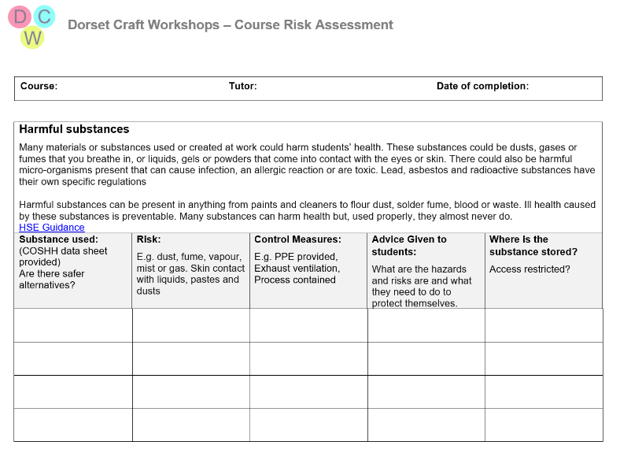
All our Tutors are individually responsible for meeting the full health and safety regulations and for providing safety advice, risk assessment and the appropriate insurance cover for their Courses, Equipment and Materials. A pro forma risk assessment template is provided for tutors which includes a section to record control measures for Harmful Substances.

https://www.hse.gov.uk/coshh/

Safeguarding
Dorset Craft Workshops is a facility for clients over the age of 18.
DCW, and the Tutors providing workshops, have a duty of care to protect adults with care and support needs who are unable to protect themselves from abuse, harm, or neglect.
Abuse may take many forms. It includes:
any form of harm such as:
- hitting, injuring, or restraining
- threatening, intimidating, or humiliating
- sexual attention or activity that is not wanted
- keeping someone on their own

any form of neglect such as:
- not giving the correct medicine
- not providing food or clothing
- not arranging the right care
- financial abuse such as:
- stealing or misusing money or property
- pressure about wills or inheritance
- discrimination such as treating someone less favourably because of race, ethnicity, religion, age, gender, disability or sexual orientation
- domestic violence and abuse

Some people over 18 years of age may be more at risk than others. This can include people who:

- Depend on others for their care.
- Are older, frail, or unable to protect themselves.
- Have mental health problems.
- Have a learning disability.
- Have a physical disability.
- Have a sight or hearing loss
- Have dementia or memory loss.
- Misuse alcohol or drugs.
- Have long term health needs.
- Are carers.

What should you do if someone tells you or you suspect they are being harmed or abused?
DO NOT
- Ask the person for more details.
- Assume that someone else is aware of the situation and will take action.
- Contact the person alleged to have caused harm.
- Promise to keep it a secret.
- Be afraid to contact Adult Social Services or Police to discuss it.
- Delay.
DO
- Stay calm and listen to them.
- Take what you are being told seriously.
- Offer support to help them stop the abuse happening.
- Be aware that medical or other evidence might be needed so keep the evidence safe.
- Write down what the person tells you in their own words.
- Contact Adult Social Services or the Police at once.

If you are being abused or harmed or suspect someone is being abused/harmed you can discuss your concerns by contacting Adult Social Services or the Police.
You can ask someone you trust to contact them for you.

Contact Dorset Council Adult Social Care: 01305 221 016 (out of hours 01305 858250)
DSAB@dorsetcouncil.gov.uk

If you think someone may be at immediate risk of serious harm contact the Police.
Telephone: 999 in an emergency and 101 at all other times.

Equality & Diversity policy
Discrimination
DCW expects its Directors, Tutors and Volunteers work together to create a safe environment and to ensure discrimination in our business and practices does not occur.
We want to work to prevent discrimination, harassment, and victimisation on the grounds of the legally protected characteristics of age, disability, gender reassignment, marriage and civil partnership, pregnancy and maternity, race, religion or belief, sex, and sexual orientation and also because of social and economic background. These can all be a barrier to creative engagement.
We also value people’s intersectional identities and want to listen to the views, experience, and influence of those who have been less represented and included in the past.
Our strategy, planning, promotion, delivery, monitoring, and evaluation is shaped by Equality Act 2010 and the Equality Duty 2011.
Types of Unlawful Discrimination
Direct discrimination – Where a person is treated less favourably than another because of a protected characteristic. However, discrimination may be lawful if there is an occupational requirement which is core to a job role and a proportionate means of achieving a legitimate aim.
Indirect discrimination – Means putting in place, a rule or policy or way of doing things that has a worse impact on someone with a protected characteristic than someone without one, when this cannot be objectively justified.
Harassment – Where there is unwanted behaviour related to a protected characteristic which has the purpose or effect of violating someone’s dignity or which creates a hostile, degrading, humiliating or offensive environment. It does not matter whether or not this effect was intended by the person responsible for the conduct.
Associative discrimination – Where the individual treated less favourably does not have a protected characteristic but is discriminated against because of their association with someone who does e.g., the parent of a disabled child.
Perceptive discrimination – Where the individual discriminated against or harassed does not have a protected characteristic, but they are perceived to have a protected characteristic.
Third-party harassment – Occurs where an employee is harassed by third parties such as service users, due to a protected characteristic.
Victimisation – Treating someone unfavourably because they have taken some form of action i.e., because they have supported a complaint or raised a grievance under the Equality Act 2010, or because they are suspected of doing so. (However, someone is not protected from victimisation if they acted maliciously or made or supported an untrue complaint.)
Failure to make reasonable adjustments – Where a rule or policy or process has a worse impact on someone with a protected characteristic compared with someone without that protected characteristic and DCW has failed to make reasonable adjustments to enable that person to overcome the disadvantage.
Positive Action
DCW believes that passive support for equal opportunities and diversity is not enough and that positive steps shall be taken. DCW is committed to:
- Recognising and developing potential which has not been used before because of past discrimination and disadvantage.
- Encouraging participation from under-represented groups.
- Taking care that when arranging courses DCW encourages and seeks responses from a wide range of tutors and courses, reflecting the diversity and composition of the community it serves.
- Ensuring that the courses it offers are as accessible as possible to all groups.
- Recognising that Improvements can be made to the physical accessibility of the building and improving facilities where possible and publishing accurate accessibility information for users.
- Making sure that users have easy access to information about DCW’s services, for example making materials available where appropriate in a variety of media, e.g. in large print or electronically. In particular, where practicable all relevant printed materials will be in Arial font at a minimum 12pt font size.
- Keeping a publicly available list of priorities for improvement, which will be reviewed at least annually.

All Directors, Tutors, and Volunteers are expected to support the organisation to meet its commitment to avoid unlawful discrimination and promote accessibility.

Data Protection (GDPR)
Definitions
- Personal data is information about a person which is identifiable as being about them. It can be stored electronically or on paper, and includes images and audio recordings as well as written information.

- Data protection is about how we, as an organisation, ensure we protect the rights and privacy of individuals, and comply with the law, when collecting, storing, using, amending, sharing, destroying, or deleting personal data.

Responsibility
- Overall and final responsibility for data protection lies with the Directors, who are responsible for overseeing activities and ensuring this policy is upheld.
- All Volunteers are responsible for observing this policy, and related procedures, in all areas of their work for the group.

Overall policy statement
- DCW needs to keep personal data about its Directors, Tutors, Volunteers and supporters in order to carry out group activities.
- We will collect, store, use, amend, share, destroy or delete personal data only in ways which protect people’s privacy and comply with the UK General Data Protection Regulation (GDPR) and other relevant legislation.
- We will only collect, store, and use the minimum amount of data that we need for clear purposes, and will not collect, store, or use data we do not need.
- We will only collect, store, and use data for:
  - purposes for which the individual has given explicit consent, or
  - purposes that are in our group’s legitimate interests, or
  - contracts with the individual whose data it is, or
  - to comply with legal obligations, or
  - to protect someone’s life, or
  - to perform public tasks.
- We will provide individuals with details of the data we have about them when requested by the relevant individual.
- We will delete data if requested by the relevant individual unless we need to keep it for legal reasons.
- We will endeavour to keep personal data up-to-date and accurate.
- We will store personal data securely.
- We will keep clear records of the purposes of collecting and holding specific data, to ensure it is only used for these purposes.
- We will not share personal data with third parties without the explicit consent of the relevant individual, unless legally required to do so.
- We will endeavour not to have data breaches. In the event of a data breach, we will endeavour to rectify the breach by getting any lost or shared data back. We will evaluate our processes and understand how to avoid it happening again. Serious data breaches which may risk someone’s personal rights or freedoms will be reported to the Information Commissioner’s Office within 72 hours, and to the individual concerned.
- To uphold this policy, we will maintain a set of data protection procedures for our Directors and Volunteers to follow.
This policy will be reviewed every two years
Data protection procedures
Introduction
- DCW has a data protection policy which is reviewed regularly. In order to help us uphold the policy, we have created the following procedures which outline ways in which we collect, store, use, amend, share, destroy and delete personal data.
- These procedures cover the main, regular ways we collect and use personal data. We may from time to time collect and use data in ways not covered here. In these cases we will ensure our Data Protection Policy is upheld.
General procedures
- Data will be stored securely. When it is stored electronically, it will be kept in password protected files. When it is stored online in a third party website (e.g. Google Drive, Crowdfunder, or Hallmaster booking system) we will ensure the third party comply with the UK GDPR. When it is stored on paper it will be filed carefully in a locked filing cabinet.
- When we no longer need data, or when someone has asked for their data to be deleted, it will be deleted securely. We will ensure that data is permanently deleted from computers, and that paper data is shredded.
- We will keep records of consent given for us to collect, use and store data. These records will be stored securely.
Mailing list (provisional)
- We do not maintain a mailing list. Should we do so this will include the names and contact details of people who wish to receive publicity and fundraising appeals from DCW .
- When people sign up to the list we will explain how their details will be used, how they will be stored, and that they may ask to be removed from the list at any time. We will ask them to give separate consent to receive publicity and fundraising messages, and will only send them messages which they have expressly consented to receive.
- We will not use the mailing list in any way that the individuals on it have not explicitly consented to.
- We will provide information about how to be removed from the list with every mailing.
- We will use mailing list providers who store data within the EU.
Contacting Tutors
- We will maintain a list of contact details of our current Tutors . We will share organisational and workshop information with the people on this list.
- Tutors will be removed from the list if they have not booked any teaching sessions for 12 months.
- When contacting people on this list, we will provide a privacy notice which explains why we have their information, what we are using it for, how long we will keep it, and that they can ask to have it deleted or amended at any time by contacting us.
- Tutors may use a third party booking system (Hallmaster) to reserve sessions. DCW will ensure the third party complies with the UK GDP
- To allow Tutors to work together to organise collective events, it is sometimes necessary to share contact details. We will only do this with explicit consent.
- Contact with individual clients will be directly with the Tutors of classes and we expect Tutors to have their own data protection safeguards and statement, for example:

‘Tutor name will keep your contact details because you have attended one of my/our craft sessions in the last 12 months. I/We only use these details to send you information about our future craft sessions. I/We do this because it is in our legitimate interest to publicise our sessions to regular attendees. Your details are stored securely by me/us, and will be deleted if you do not attend a session for 12 months. You can ask us to amend or delete your details at any time by contacting me/us on: Phone/email’
Contacting volunteers
- We will maintain a list of contact details of our volunteers. We will share volunteering opportunities and requests for help with the people on this list.
- People will be removed from the list if they have not volunteered for the group for 12 months.
- When contacting people on this list, we will provide a privacy notice which explains why we have their information, what we are using it for, how long we will keep it, and that they can ask to have it deleted or amended at any time by contacting us.
- To allow Volunteers to work together to organise for the group, it is sometimes necessary to share volunteer contact details with other volunteers. We will only do this with explicit consent.
Contacting Directors
- The Directors need to be in contact with one another in order to run the organisation effectively and ensure its legal obligations are met.
- Directors contact details will be shared among the Directors.
- Directors members will not share each other’s contact details with anyone outside of the Directors, or use them for anything other than DCW business, without explicit consent.
This policy will be reviewed every two years

1/24 work quoted for from Dorset Fire Protection
There are no plans to run courses or workshops for under 18s. Tutors wanting to do so in the future should talk to the Courses Director to make sure the relevant DBS & Safeguarding procedures are in place.

